**DAILY ONLINE ACTIVITIES SUMMARY**

|  |  |  |  |  |  |  |  |  |
| --- | --- | --- | --- | --- | --- | --- | --- | --- |
| **Date:** | **07/06/2020** | | | | | **Name:** | **LAVANYA D M** | |
| **Sem & Sec** | **4th Sem A Sec** | | | | | **USN:** | **4AL18CS041** | |
| **Online Test Summary** | | | | | | | | |
| **Subject** | | **nil** | | | | | | |
| **Max. Marks** | | **nil** | | **Score** | | | **nil** | |
| **Certification Course Summary** | | | | | | | | |
| **Course** | **Building VMware lab** | | | | | | | |
| **Certificate Provider** | | | **Bit degree** | | **Duration** | | | **1week** |
| **Coding Challenges** | | | | | | | | |
| **Problem Statement: 1)**Write a C++ Program to swap two numbers using friend as a bridge concept.  **2)** Java Program To Subtract Two Matrices | | | | | | | | |
| **Status: executed** | | | | | | | | |
| **Uploaded the report in Github** | | | | | **Yes** | | | |
| **If yes Repository name** | | | | | <https://github.com/lavanyamurthi/lockdown-coding/tree/master> | | | |
| **Uploaded the report in slack** | | | | | **Yes** | | | |

Online Test Details:

Certification Course Details:

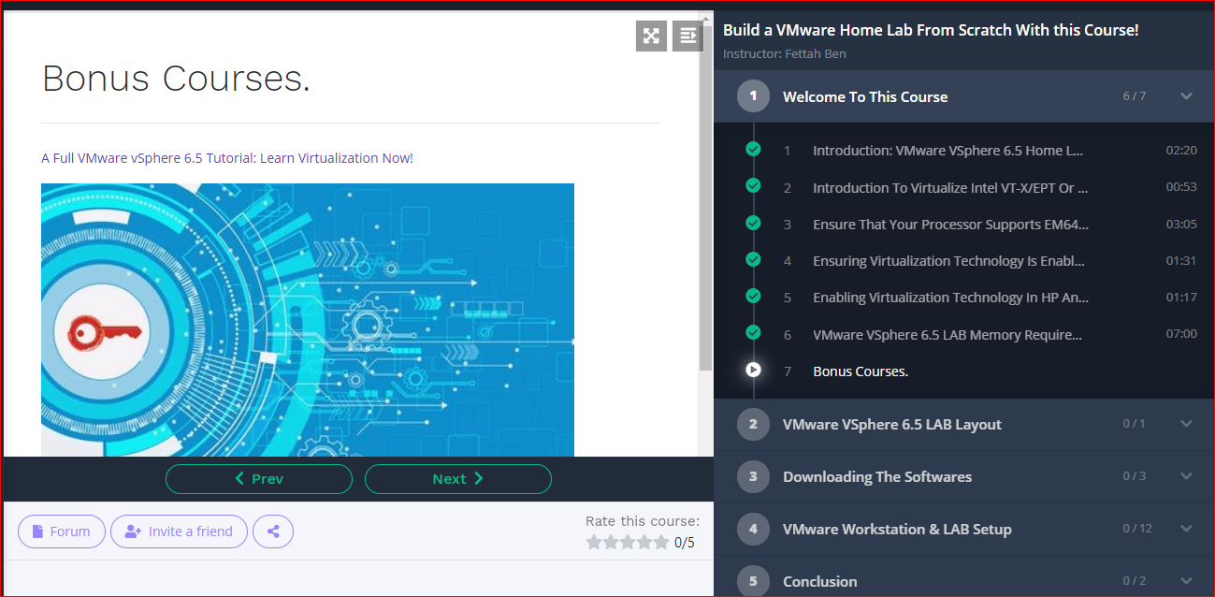

Coding Challenges Details: Every day we are given with new question of coding related to the language of java and c. it seems interesting how we imbibe our self in depth to understand the logic ,break it and then code for it.

Today’s question was :

**Problem 1:** Write a C++ Program to swap two numbers using friend as a bridge concept.

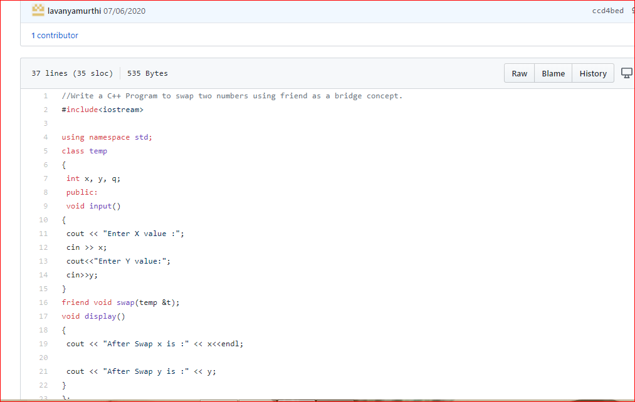

# Problem 2: Java Program To Subtract Two Matrices

